**Project 1 – Part 1**

Richard L. McCormick

Northern Arizona University

CS470: Artificial Intelligence

Prof. Dr. Lan Zhang

February 2nd, 2024

1. Save the file attached here, and feed it to your loadBoard function to get this board loaded into your solver.

1. Run your printBoard function to show us the loaded board.

1. Run your possibleMoves function on the board for position (3,3) #remember, all indexing starts at (0,0) in the top left corner!

1. Run your possibleMoves function on the board for position (2,1)

1. Run your legalMoves function on the board for position (1,2), assuming you have a past path of ( (1,0),(2,0),(2,1),(2,2) )

1. Run your legalMoves function on the board for position (2,2), assuming a path of ( (1,1),(1,2),(1,3),(2,3),(3,2) )

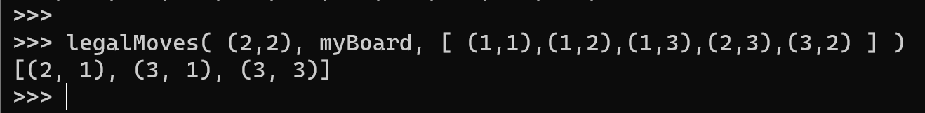

1. Run examineState on the board at (0,3), with a past path of ( (1,1), (0,1),(0,2) )

1. Run examineState on the board at (0,0), with a past path of ( (3,3), (2,2), (1,1) )

1. Run examineState on the board at (3,3), with a past path of ( (2,2),(2,1),(2,0),(3,0),(3,1),(3,2) )

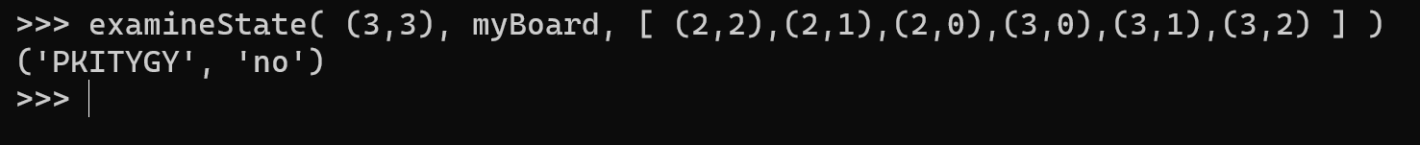

__author__ = "RLM443"

**import** **math**

"""

CS 470 - Artificial Intelligence

Project One - Part One

Richard McCormick

Northern Arizona University

"""

**def** **loadBoard**( filename ):

"""

Function: loadBoard

Description: Loads a Boggle board from a text file.

Params: filename Name of file to open

Return: 2D Game Board Array

"""

file = open( filename, 'r' ) # Open the file

text = file.read().split() # Read the file, split into letters

file.close() # Close the file

# Get the size of the board by taking the root of the number of letters

size = int( math.sqrt( len( text ) ) )

# Create a 2D matrix of the board

finalBoard = [[**0** **for** i **in** range(size)] **for** j **in** range(size)]

i=**0** # Establish a counter

**for** y **in** range(size): # Iterate Y-Axis

**for** x **in** range(size): # Iterate X-Axis

finalBoard[x][y] = text[i] # Fill the board slot with letter

i = i + **1** # Increment counter

**return**( finalBoard ) # Return completed board

**def** **printBoard**( board ):

"""

Function: printBoard

Description: Prints a given Boggle board to screen.

Params: board Board to print out.

Return: None

"""

N = len( board ) # Get board size (N)

**for** y **in** range(N): # Traverse Y axis

**for** x **in** range(N): # Traverse X axis

**print**( board[x][y], end=" " ) # Print current letter

**print**("**\n**") # At end of row, print new line

**def** **possibleMoves**( cords, board ):

"""

Function: possibleMoves

Description: Returns a list of possible moves given a set of

coordinates and a game board.

Params: cords Co-ordinates to check.

board Board to check.

Return: Array of coordinates

"""

x = cords[**0**] # Get X coordinate

y = cords[**1**] # Get Y coordinate

possibleMoves = [] # Initialize empty list of possible moves

N = len( board ) # Get size of board

**for** i **in** range( x-**1**, x+**2** ):

# Search the X axis first, within 1 space of the current X Coord

**if**( i >= **0** **and** i <= N ):

# If coord is negative or outside board, it is not valid.

x_temp = i

# Everything else is valid, so add to list.

**for** j **in** range( y-**1**, y+**2** ):

# Repeat loop for the Y axis (within 1 space either way).

**if**( j >= **0** **and** j <= N ):

# Coord must be non-negative and inside board.

y_temp = j

# Take the valid Y coord.

possibleMoves.append( ( x_temp, y_temp ) )

# Add both coords to list.

possibleMoves.remove( cords ) # Self is not a valid move, remove.

**return**( possibleMoves ) # Return list.

**def** **legalMoves**( cords, board, history ):

"""

Function: legalMoves

Description: Gets all legal moves for a current position and board.

Params: cords Coordinates to check.

board Board to check.

history History of the board / current path.

Return: Array of coordinates

"""

# Get all possible moves for current position.

legalmoves = possibleMoves( cords, board )

# Iterate over past moves.

**for** move **in** history:

# Check if move is in legal moves list.

**if** move **in** legalmoves:

# If move has been made, it is not legal. Remove.

legalmoves.remove( move )

# Return list of legal moves.

**return**( legalmoves )

**def** **examineState**( cords, board, history ):

"""

Function: examineState

Description: Examines the current state of the board, and checks to see

if a word in the dictionary has been reached.

Params: cords Coordinates to check.

board Board to check.

history History of the board / current path.

Return: Tuple ( Current Word, In Dictionary(y/N) )

"""

myHist = history # Local history copy

newcord = tuple( [ cords[**0**], cords[**1**] ] ) # Get current cord as tuple

myHist.append( newcord ) # Append current cord to history

word = "" # Establish var for current 'word'

inDict = "no" # Establish var for if current word is in dictionary

fileobj=open( "twl06.txt" ) # Open dictionary

lines=[] # Convert words in dict to list

**for** line **in** fileobj: # Iterate over lines in dict...

lines.append( line.strip() ) # Strip whitespace and add to word list

**for** coord **in** history: # For each word in hist...

word = word + board[coord[**0**]][coord[**1**]] # Append the letter...

**if** word.lower() **in** lines: # Convert finished word to lower

inDict = "yes" # If word in dict, set to "yes"

**return**( word, inDict ) # Return word and inDict bool